REPORT for Experiment 13
Experiment Title：Marine microbes in pollution control

Instructor(s)：Pinmei Wang

Lab Location：海工楼

Date Performed：2024.11.26

- Introduction
Oil is a common cause of water pollution in the environment. Microorganisms in the natural environment play an important role in their degradation process.
There are several mediums to screen oil-degrading microorganisms, of which one is adding neutral red into the oil-degradating medium. It is easy to observe results with naked eyes. If the microbes could degrade the oil in medium and change the pH of the medium, the neutral red indicator around/on the microbial colonies will turn red.
In this practice,our goal is to detect the ability of degrading oil of your isolated bacterial using this method.
- Experimental Purpose
- Be able to screen or initially detect the ability oil of oil degrading bacteria.
- Know the usage of neutral red in oil-degrading microbes screening
- Experimental Procedure
EXP 13A
- Label the base
- Repeat to streak the four strain cultures on the “OIL”,”NB”and”OIL/NB”plate,respectively.
- Allow the drops to soak into the agar for at least 15min Parafilm the plates and invert plates so base is on top,and then incubate plates at 30℃.
EXP 13B
- Observe and record the change for the color around/on the strains
- Record results in worksheet 13.
- Equipment and materials
1 x LB agar plate (labeled “B”)
1 x LB plus Oil plate (labeled “OI”)
1 x LB plus Neutral Red plate (labeled “NB”)
1 x LB plus Oil and Neutral Red plate (labeled “OIL/NB’)
Fresh liquid culture of Pseudomonas aeruginosa in 1.5 ml tube(labeled “Pa ”)
Fresh liquid culture of Staphylococcus epidermidis in 1.5 mL tube(labeled “Se”)
Fresh liquid culture of E. coli in 1.5 mL tube(labeled “Ec”)
Fresh liquid culture of your strain in liquid culture (labeled “Y”
Loop
5. Record and Results
WORKSHEET 13
Strain | Growth (Yes/No) |  |  |  | Phenotype (color, oil dot etc.)
Strain | LB | OIL | NB | OIL/NB | LB | OIL | NB | OIL/NB
P.aeruginosa (Pa) | Y | Y | Y | Y | N | N | N | Y
S.epidermidis  (Se) | Y | Y | Y | Y | N | N | N | Y
E. coli  (Ec) | Y | Y | Y | Y | N | N | N | N
Your strain  (Y) | Y | Y | Y | Y | N | N | N | Y

6. Discussion
1) Does your strain show oil-degrading ability in this test? Explain the test results.
Yes,Our sample (bottom left) is visibly red
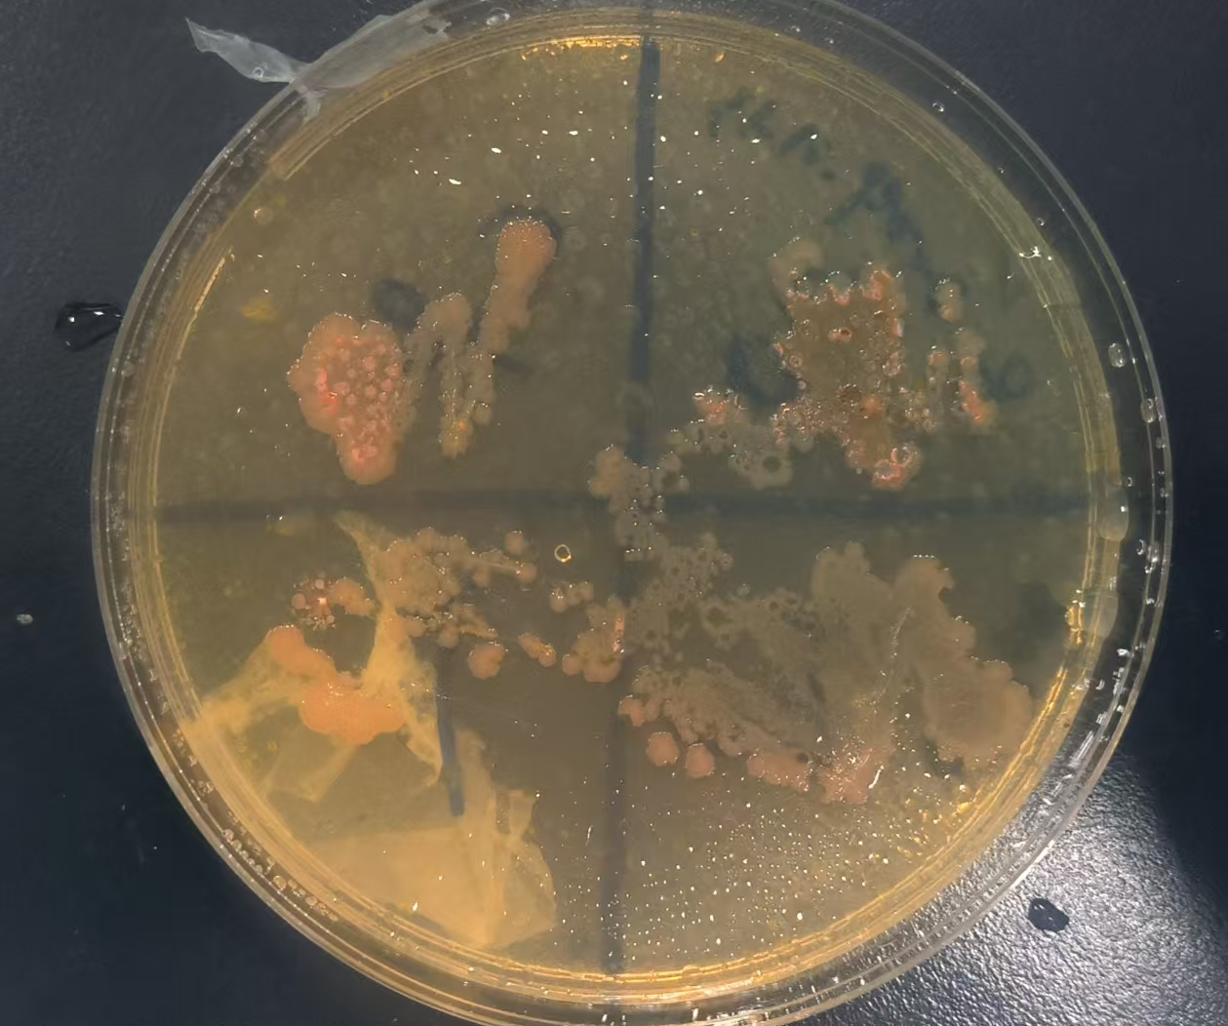
2) Supposing your strain shows oil-degrading ability, do you think it could be used to completely remove oil contamination in ocean? Explain your answer.
I don't think so, because seawater itself is very large, and it is difficult for bacteria to degrade completely, and even if there are bacteria that can degrade quality, such a large number will affect the marine ecology

